Milestone #2
SDR Design Goals and reasoning:
- Simplicity and reliability
- Low cost and accessibility of components
- Educational demonstrating both analog and digital signal processing
The goal of this project is to design and implement a software-assisted AM radio receiver capable of receiving and demodulating amplitude modulated (AM) signals in the standard broadcast band. The design combines analog front-end circuits with digital processing using a Raspberry Pico to create a flexible and cost-effective receiver.
Reasoning:
- AM modulation was chosen because it is simpler to implement and easier to demodulate compared to FM or SSB.
- A mixer + clock (local oscillator) is used to shift the signal to a lower frequency for easier processing.
- An ADC allows for conversion of analog signals into digital form, enabling software signal processing.
Specifications:
- Frequency range
  - 535–1705 kHz
- Modulation Type
  - AM (Amplitude Modulation)
- Minimum discernible signal
  - 10 µV
- User Interface
  - Rotary encoder
  - push buttons
  - LCD/OLED
- Processing Hardware
  - Raspberry Pi Pico RP2040 microcontroller
- Audio Output
  - Headphones or speaker
- Size/Weight
  - Handheld (Walkman size plus antenna)
- Power requirements
  - 5V via USB-C
- Software and computer requirements
  - Nice UI, easy to navigate and makes sense
- Special Features:
  - SD/.WAV recording
  - Storage – SD card or direct over USB
- Cost
  - $40 – $50 depending on components
System Architecture Overview
The receiver follows a Direct Conversion (Zero-IF) architecture. The radio frequency is mixed down to baseband (audio) using a high-speed analog switch driven by a programmable clock.
Signal Path & Sub-Circuits
A. The Front-End (Antenna & Filter)
- Antenna
- Protection: Back-to-back 1N4148 diodes to ground to prevent ESD damage.
- Pre-selector: A Passive Band-Pass Filter (BPF) designed for 500 kHz – 1.8 MHz. This prevents "images" from FM or Shortwave bands from entering the mixer.
- Buffer: A single-transistor JFET buffer (e.g., J310) to match the high-impedance antenna to the low-impedance detector.
- Transformer: Feeds into demodulator.
B. The Demodulator
- Switching IC: A high-speed analog demultiplexer.
- Operation: The switch rotates through 2 positions at the target frequency.
C. The Clock Engine (Digital Tuning)
- Clock Gen: Si5351A controlled via I2C by the Pi Pico.
- Frequency Logic: To listen to 1800 kHz, the Si5351 outputs 1800 kHz.
D. Post-Mixer Amplification (The "Bridge")
- Dual Op-Amp: NE5532 or TL072 configured as differential amplifiers.
- Biasing: Signal is biased for compatibility with the Pi Pico ADC.
- Filtering: Active Low-Pass Filter at 10 kHz to remove switching noise.
E. The Output Split
- Digital Branch: Signal feed into Pico ADC (GP26/27).
- Analog Branch: Signal passes through a 10µF DC-blocking capacitor -> Audio Potentiometer & Power Amplifier -> Speaker/3.5mm Jack.
3. Control & UI (The Pi Pico)
- Input: Rotary encoder for frequency selection.
- Display: I2C OLED to show the current frequency.
- Software: The Pico runs a loop that calculates the frequency for the Si5351 and can optionally perform an FFT on the ADC data to show a "spectrum" of the AM band.
Block Diagram:
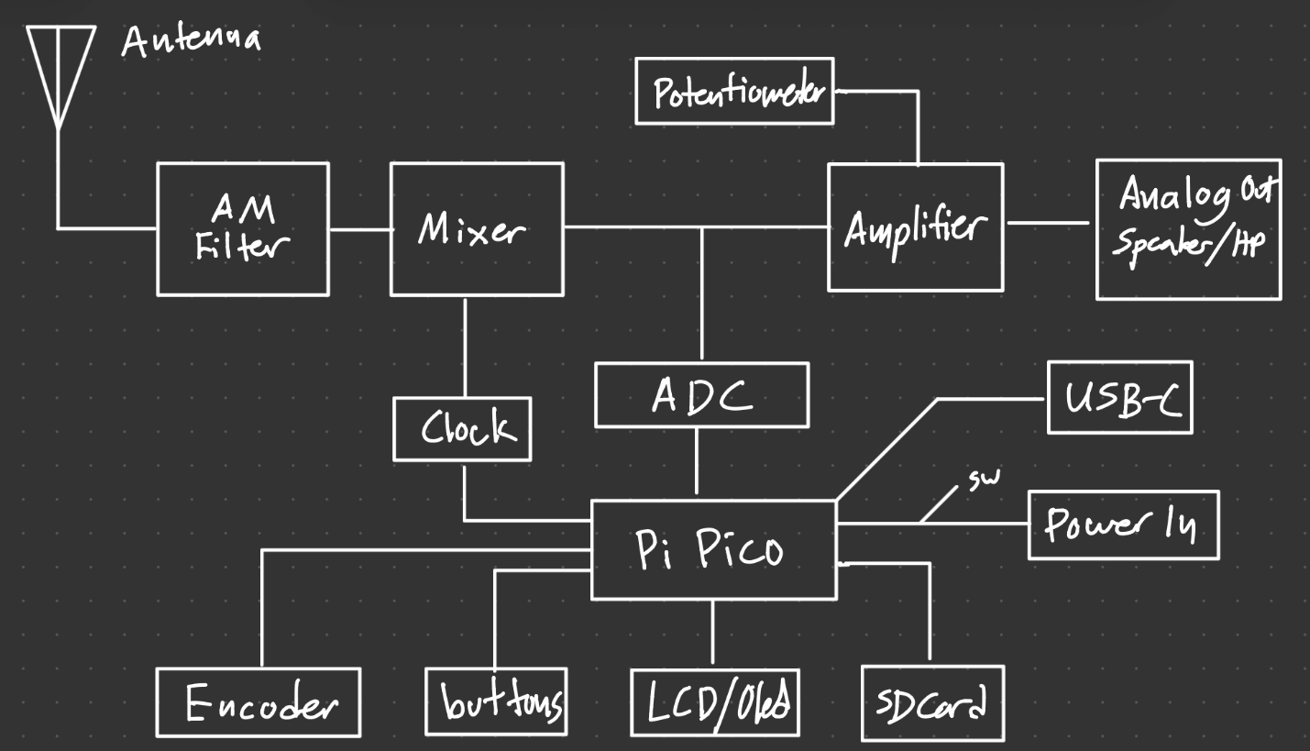
Explanation:
- Antenna
  - Receives electromagnetic AM signals from the air.
- AM Filter
  - Filters the incoming signal to isolate the desired frequency range and reduce interference from other signals.
- Mixer + Clock (Local Oscillator)
  - Local Oscillator acts like a signal generator, creating new signals. The mixer then combines the signal, lowering the frequency, making the radio process a lower frequency. Lower frequency allows for easier filtering
- Signal Split Path
  - One path goes to the ADC
  - Another goes through an amplifier for audio output
- ADC
  - Convert the analog signal into digital samples.
- Amplifier and Potentiometer
  - Amplifies audio signal
  - Potentiometer controls volume
- Analog Output
  - Outputs the recovered audio signal thorough speaker or headphones
- Pi Pico
  - Processes the sampled signal
  - Controls display and storage
  - Can demodulation extracting audio from AM signal
- User Interface
  - Encoder: tuning frequency
  - Buttons: controls modes
  - LCD/OLED: display frequency, status
- Power Supply
  - USB-C 5V
- SD card
  - Stores recorded signals or processed data.

